DSR ShareFile Shortcut not Opening
If you receive the below error message when trying to open your DSR folder, it means that Citrix Files is not running correctly on your computer. Follow the instructions below to confirm that Citrix Files is launched and logged in before reaching out to IT for further assistance.
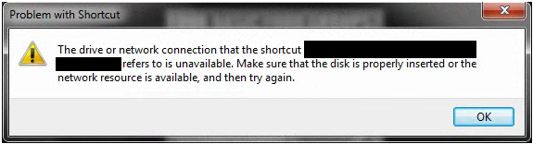

- Open the icon tray in the bottom right corner of the start bar on the computer. Look for the ShareFile icon to be present, with no warning symbols

- If there is no ShareFile icon present, follow these steps below.
  - Open the start menu by clicking the bottom left icon
  - Search for the program Citrix Files in the search bar that appears:

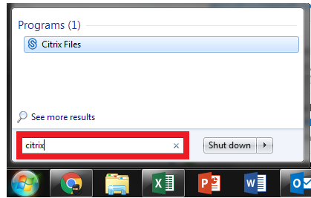
  - From the program list that appears, select Citrix Files:
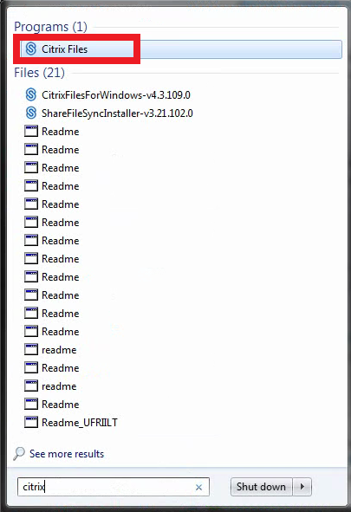

- If you have an icon with a warning symbol follow the below steps.

  - Click on the ShareFile icon in the tray.
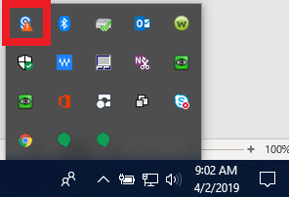

  - A popup will appear that shows you are not logged in.
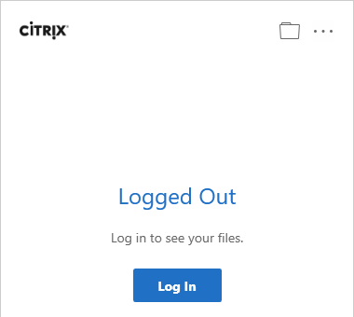

  - Select the Log In button
  - It might ask for the company code, if so type fbrest
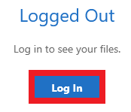
  - Begin to type your store e-mail address, until a dropdown appears prompting for autofill. Select this dropdown to auto-complete your login information.
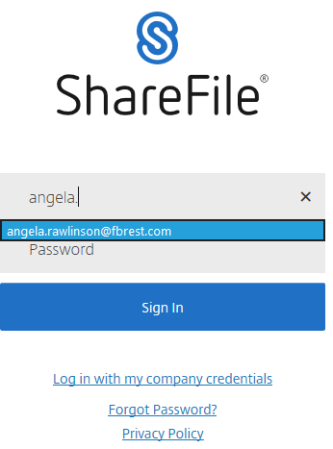
  - Select Sign In.

- After these steps have been taken, attempt to open the DSR folder again. If issues still persist, contact support@fbrest.com for assistance.

